**Improvements**:

1. Secure and Safe login, HTTPS and SSL.
2. Parallex Home Page with basic tabs like HOME, ABOUT US, CONTACT ,LOGIN. SIMILAR to existing page <http://www.swapieze.com/> .
3. An animated video on ‘’how it works’’.(if possible)
4. Login with linkedin / create new account.
5. A profile page, kind of similar to linked in. shows experience, projects, skills , photo, summary etc .Can sync this if login with linkedin account.

Example.

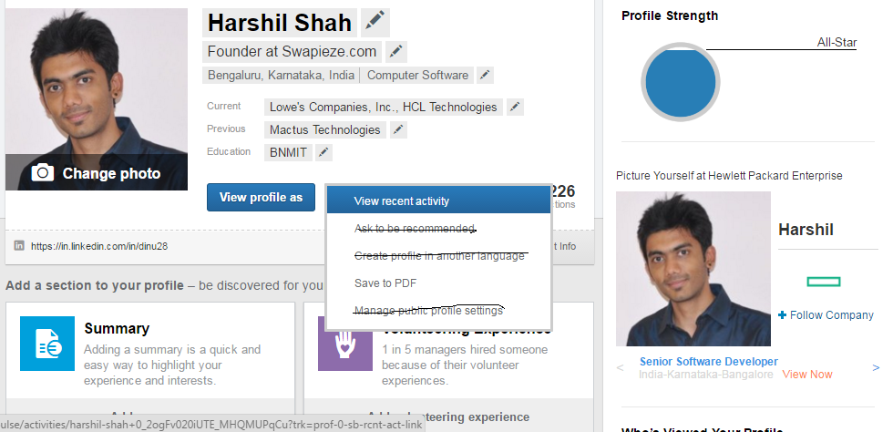

1. There buttons: ‘UPDATE PROFILE’ ‘FIND SWAPS’ ‘ALREADY CONNECTED’ present on login.
2. **PROFILE Strength** required.
3. The profile can be updatable from ‘UPDATE PROFILE’ button.
4. ‘ALREADY CONNECTED’ will show the people the user has send a connect already (step 13).
5. Profile can have multiple skills and multiple swap locations to be added. Currently it is one data per field.

Eg: SKILL1 : can enter only one skill

SKILL2 : can enter only one skill

This should be updated to handle multiple

SKILLS : oracle,SAP etc. like it is in NAUKRI.com so that alerts can be generated as individual skills searches. Same for locations(not more than 3)

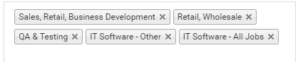

1. A button called ‘FIND SWAPS’ , that will give out swap results in terms of pins like in pinterest.com.

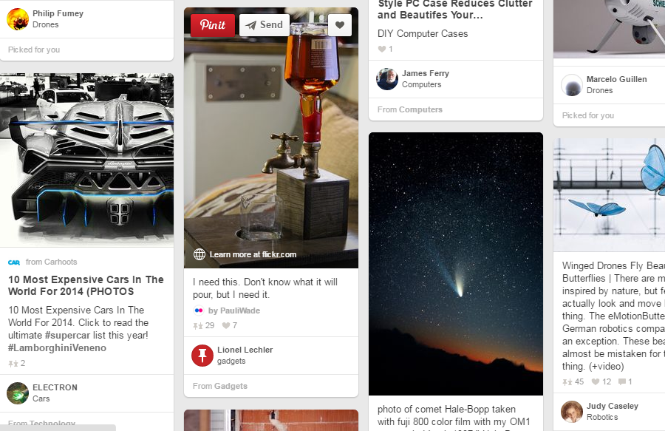

1. On hover (keeping the mouse on the card) it show the ‘CONNECT’ button . If the user has already connected in past , disable this button. (like send button in pinenterest), disable this button after 10days.
2. On hover (keeping the mouse on the card) show a button to view the **COMPLETE PROFILE**. (like pinit button in pinenterest)
3. Connect button will send mails to both the parties, the user as well as the person who he connects to. After this the Connect button is disabled. The connected people are shown in ‘ALREADY CONNECTED’ (step 8).
4. The search logic is defined , and will let you know after the pricing and resource is confirmed.
5. This should also include options to reset you password, forgot password and disable your profile from visibility. This will turn off sending notification mails to the user also.
6. HTML content mail for confirming your account on login / resetting and updating of password.
7. Required the most efficient database system, currently we use MYSQL.
8. Social connect buttons on home page.

Questions:

1. How much of DB storage is required to store a complete profile of a user(more or less like in linkedin profiles) ? say for 1Million users?
2. How much will be the approximate cost and charges for both hardware(servers) and software?
3. How will will you take to make the same in android and ios app?

**KINDLY LOGIN TO SWAPIEZE.COM TO KNOW HOW IT CURRENTLY WORKS.**